# Setting up a Load Balancer in AWS for Conjur Master Cluster.

1. Creation of the Load Balancer itself.  
   Within the EC2 panel of the same region, select Load Balancers on the left and then click on **Create Load Balancer**.  
   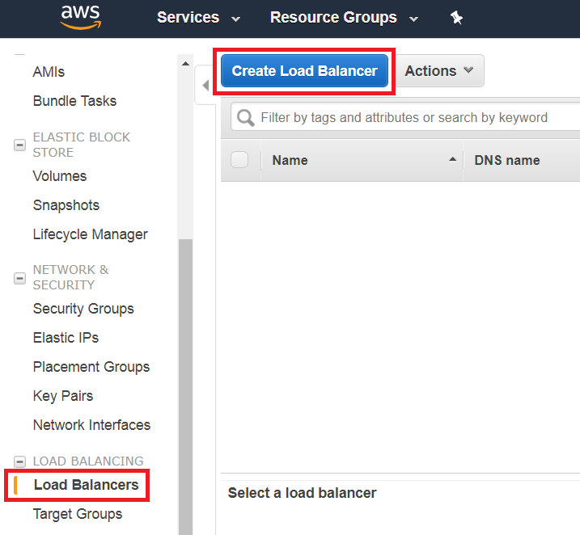
2. Select **Network Load Balancer**.  
   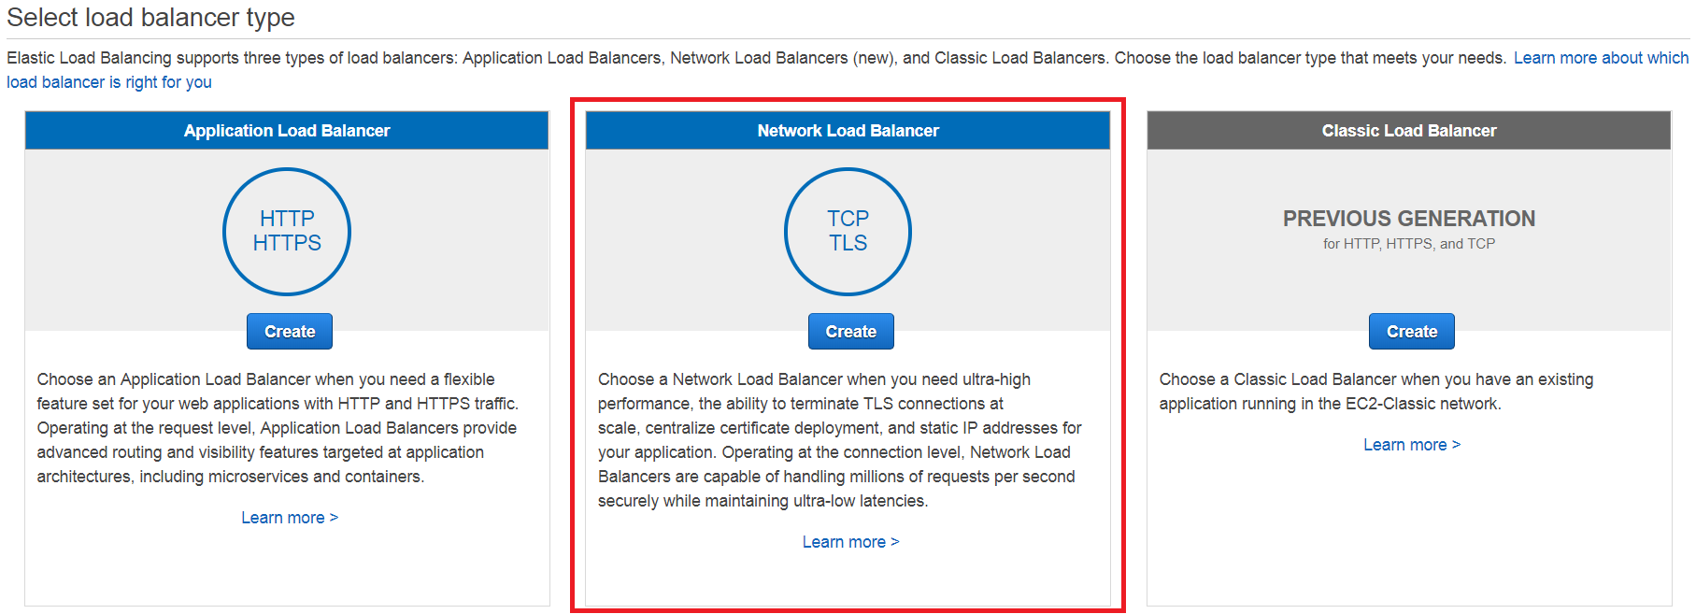
3. Choose a name and add TCP listeners for ports 443, 1999 and 5432.  
   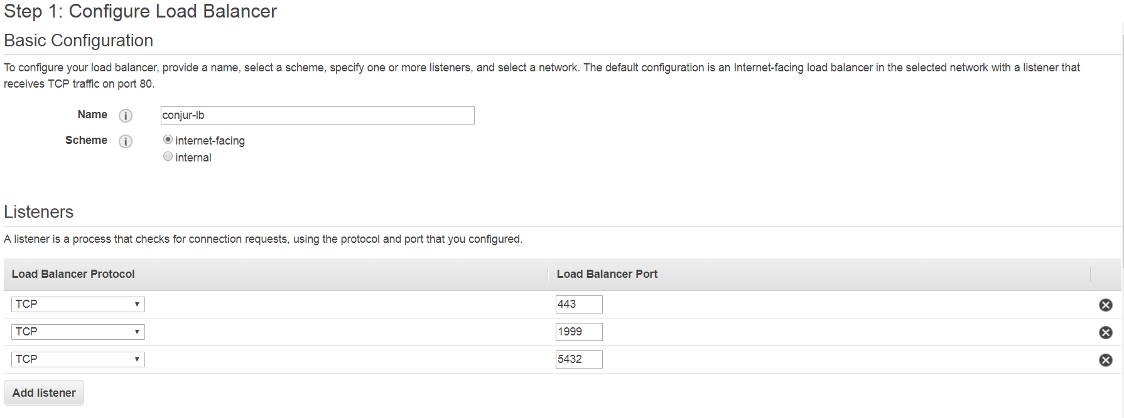  
   IMPORTANT: For production purposes you might want to have the Load Balancer set to be internal and not internet-facing.  
   To further increase the security for your load balancer you can choose TLS (Secure TCP) as part of the protocol. This will require an additional step and certificates to be installed separately.
4. Choose all necessary Availability Zones as requested from the VPC where Conjur is deployed.  
   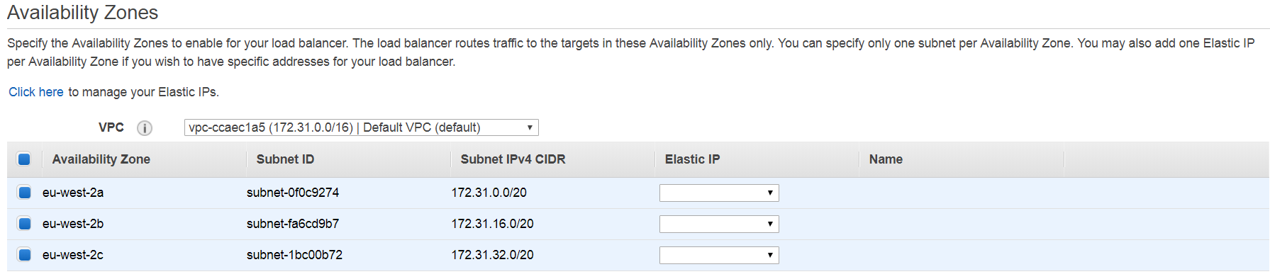
5. Choose next if you chose TCP or configure your certificates for TLS.
6. Configure Routing by adding a new Target Group.  
   Target Type : Instance  
   Protocol : TCP  
   Port : 443  
   Set Health Checks over HTTPS over Path */health*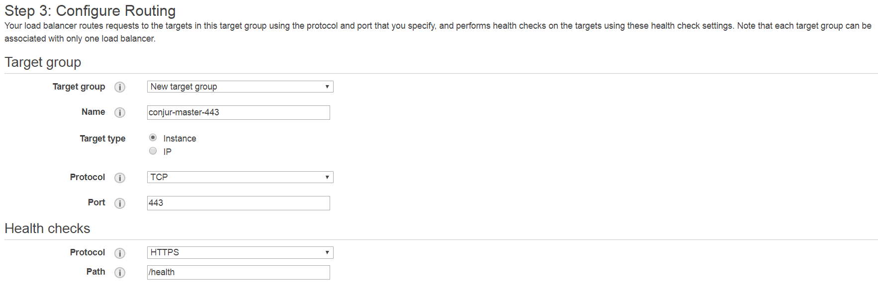There is no need to override the port in the advanced health checks settings for port 443 as we will be using the same traffic Port.
7. Select your Conjur instances for Master and Standbys and click on **Add to registered**.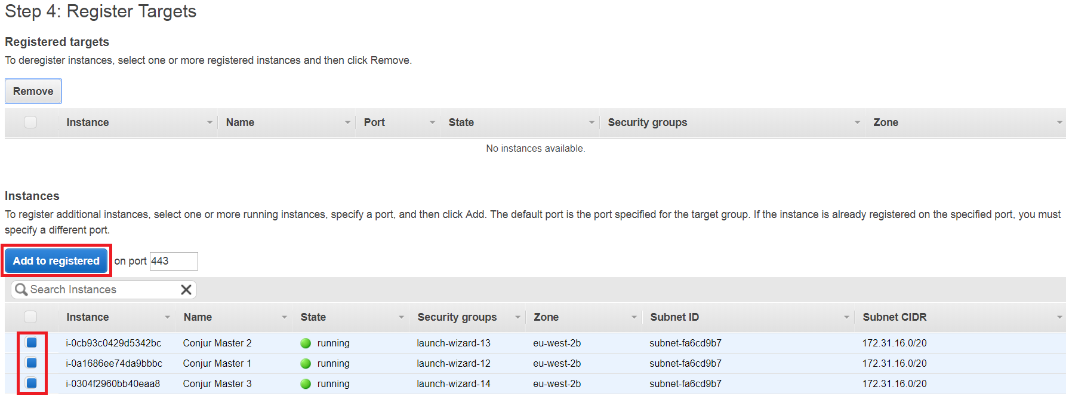
8. They will be added to the registered targets for port 443  
   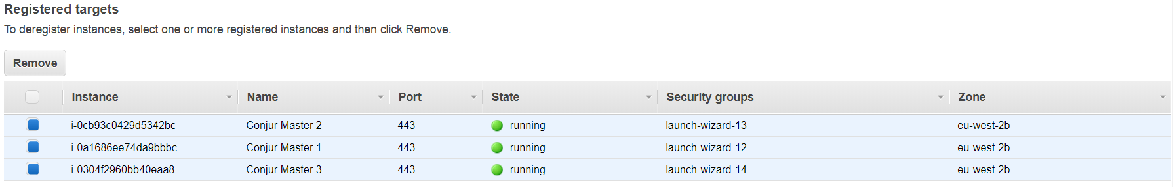
9. Click **Next: Review**.
10. Review the settings and then click **Create**.
11. Click **Close** once the load balancer has been create and move to *Target Groups*. Then click on **Create target group**.  
    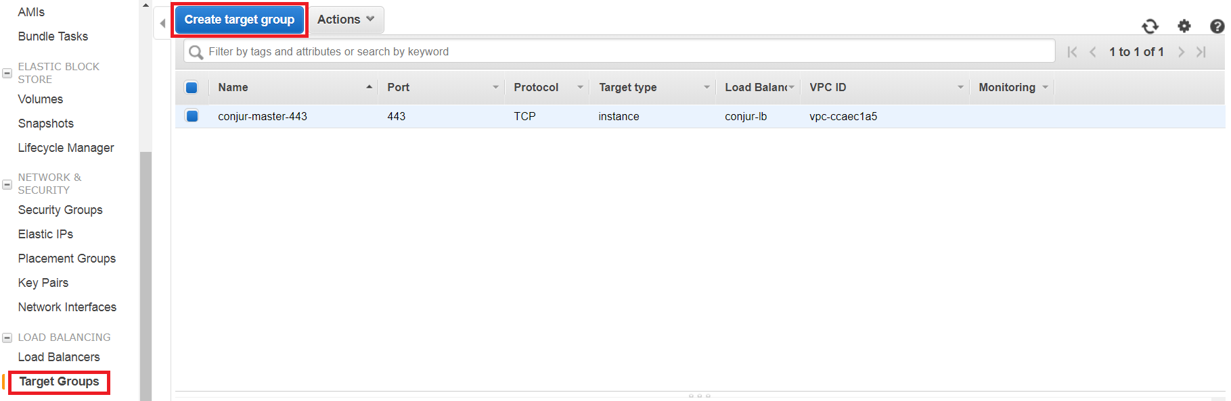
12. Set the target group to TCP on port 1999, with the Health check settings to use HTTPS as Protocol and */health* as Path.  
    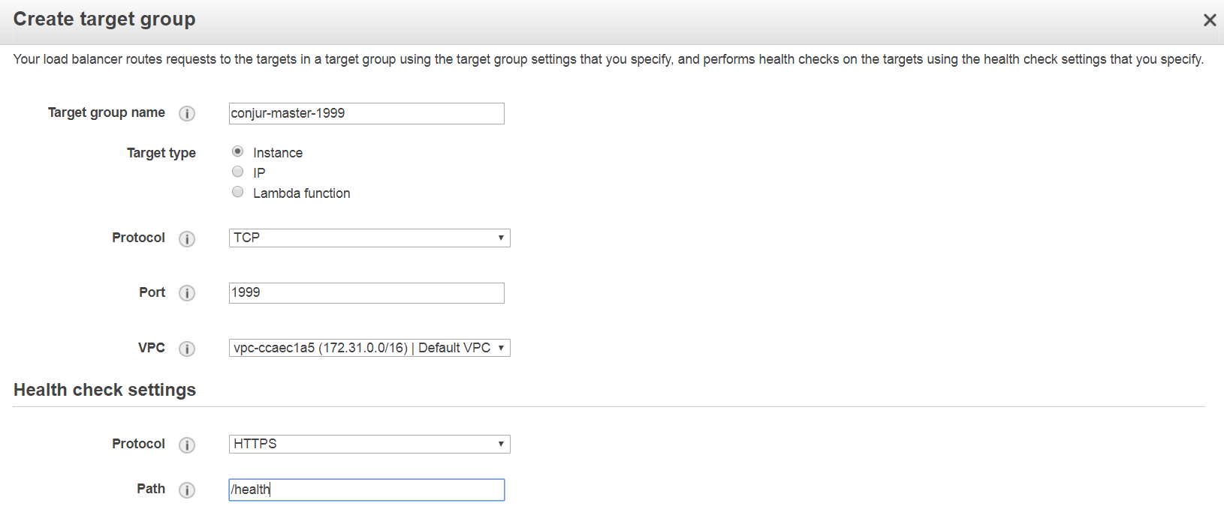
13. Under Advanced health check settings, set the Port override to use 443.  
    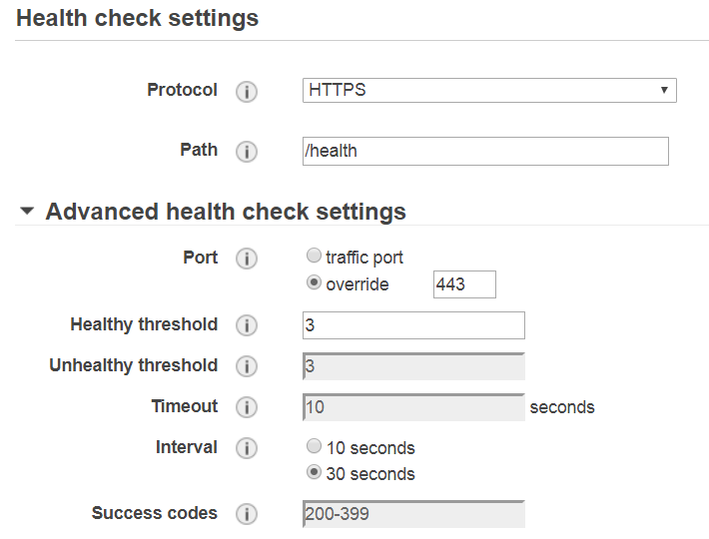
14. Click on **Create**.
15. Click again on **Create target group** and repeat the same as steps 12 and 13, this time setting the target port to 5432.  
    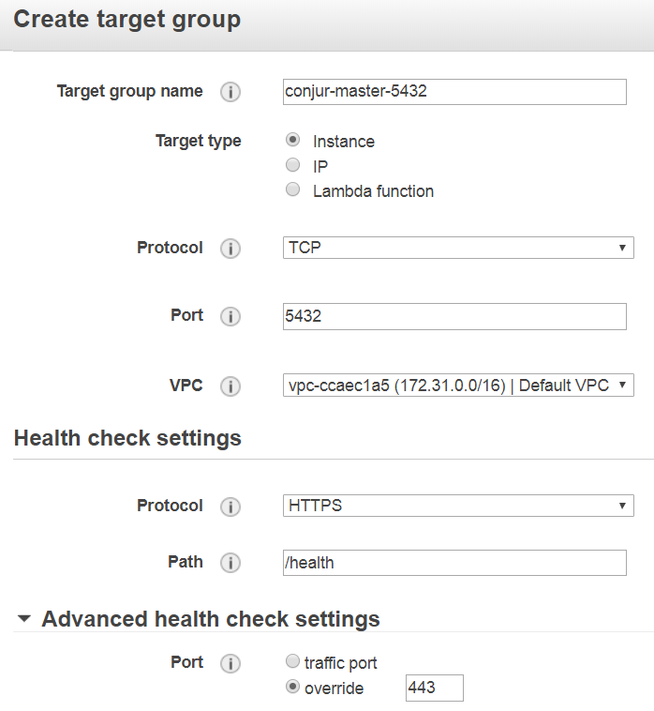
16. Click again on **Create**.
17. Going back to Load Balancer, select the newly created Conjur load balancer and then click on the Listeners tab.  
    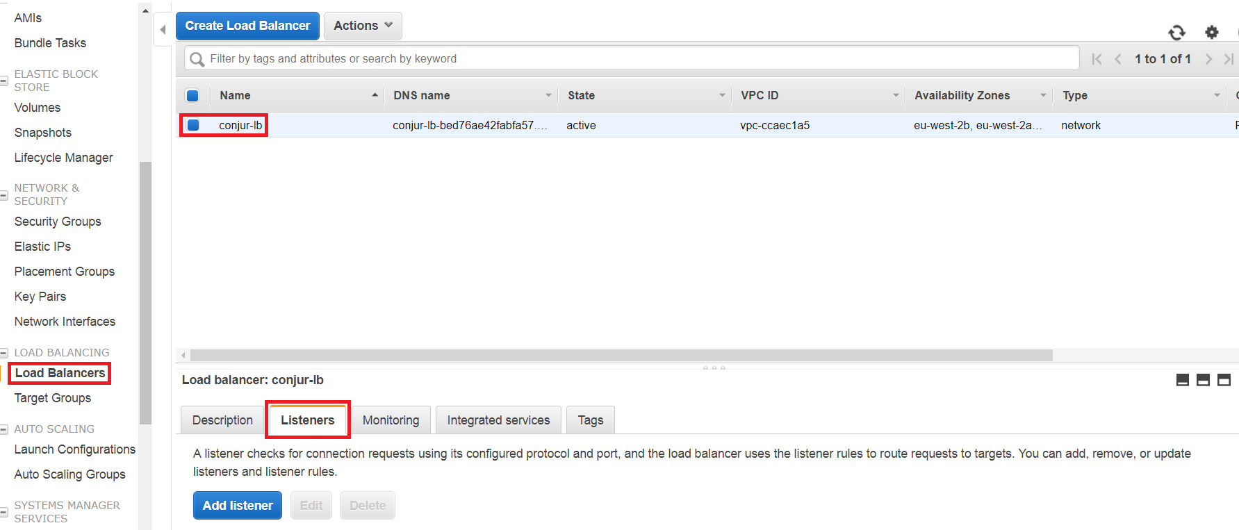
18. Select the first listener for port 1999 and then click **Edit**.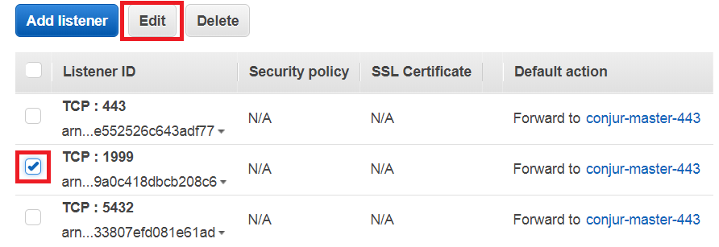
19. Click on the **bin** for the available default action.  
    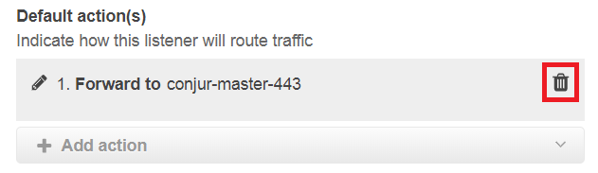
20. Click on **Add action** and then on **Forward to…**  
    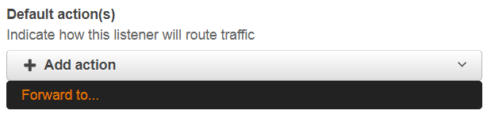
21. From the drop down box, choose the relevant target group for port 1999.  
    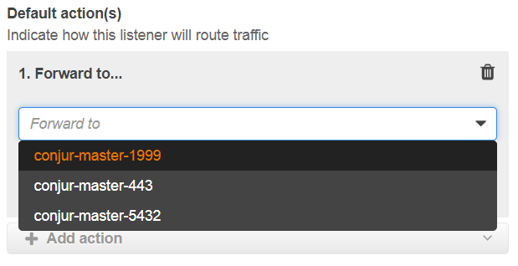
22. Click on the blue tick box button.  
    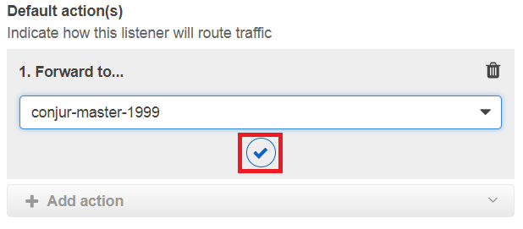
23. Click **Update** on the top right of the screen and go back to the load balancer’s list of listeners.
24. Repeat from step 18 to step 22 for the next listener for port 5432, selecting the right target group. Your list should look like this.  
    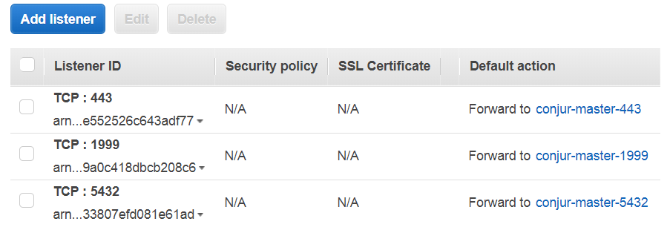
25. Assuming your instances have the right Security Groups settings, providing inbound access to ports 443, 1999 and 5432, by going through each Target Group you should see that the targets are now showing one healthy instance in the cluster, which is your active Conjur Master and where the traffic will be redirected to.  
    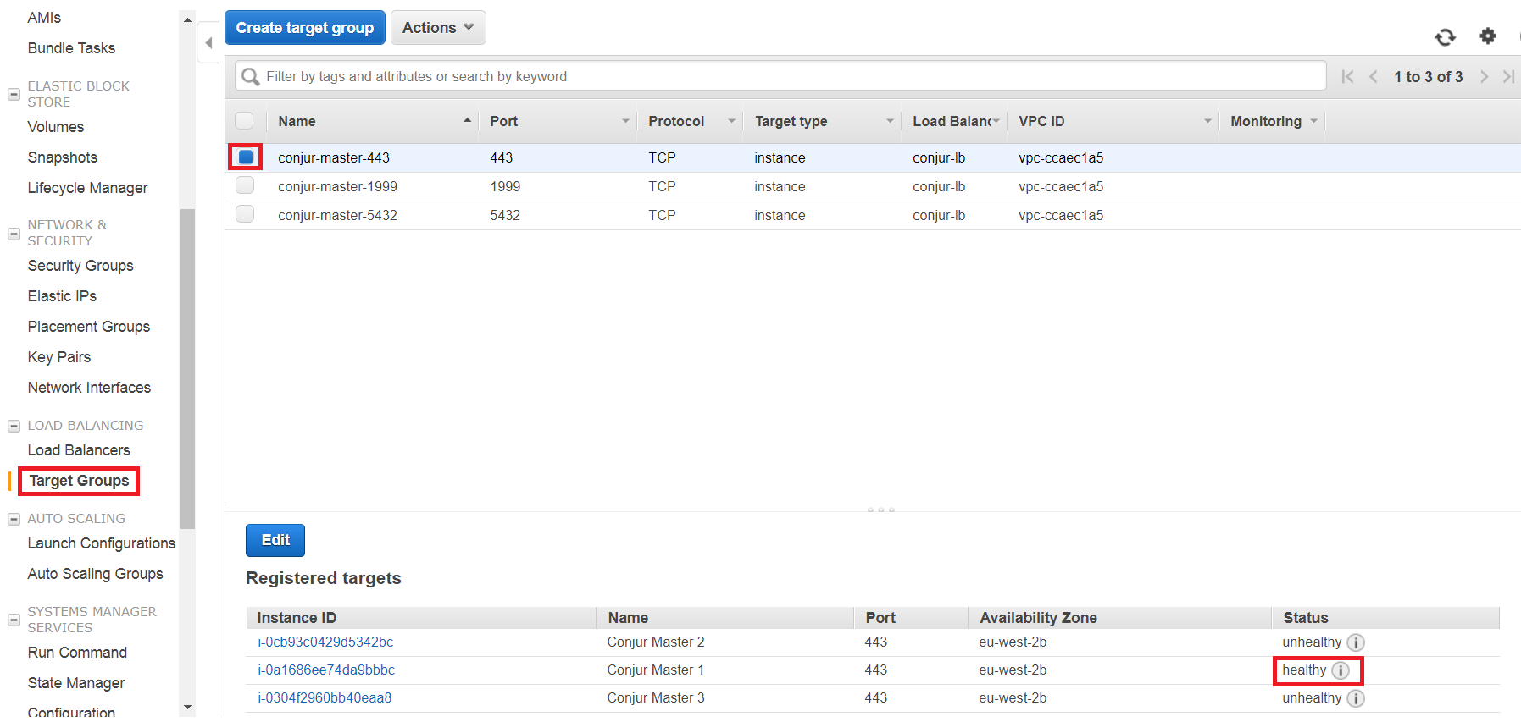
26. Test by connecting to the conjur UI and to the /health/ page, using your Load Balancer’s public DNS name. ( *https://<load-balancer-dns>/ui* and *https://<load-balancer-dns>/health* )